
VILNIUS UNIVERSITY
ŠIAULIAI ACADEMY
BACHELOR PROGRAMME SOFTWARE ENGINEERING

Object-Oriented Programming assignment no 2

Student: Muhammad Abdul Rehman
Lecturer: Donatas Dervinis

Šiauliai, 2025

Tasks:
Create PHP a program to calculate the mathematical function 3x + 1 ( Collatz conjecture )

Code:
<?php
// Collatz Conjecture Program
echo "<h2>Collatz Conjecture Calculator</h2>";

// HTML form to take user input
echo '<form method="post">
Enter a number: <input type="number" name="num" required>
<input type="submit" value="Calculate">
</form>';

// Check if user submitted a number
if(isset($_POST['num'])) {
$x = $_POST['num'];
echo "<h3>Sequence:</h3>";
while($x != 1) {
echo $x . " → ";
if($x % 2 == 0) {
$x = $x / 2;
} else {
$x = 3 * $x + 1;
}
}
echo "1";
}
?>

Output:
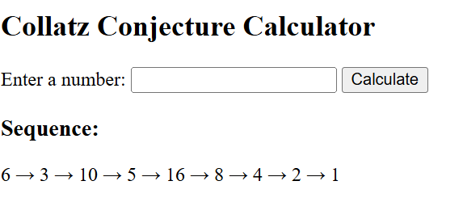
Figure 1: Input 6 and it gives output

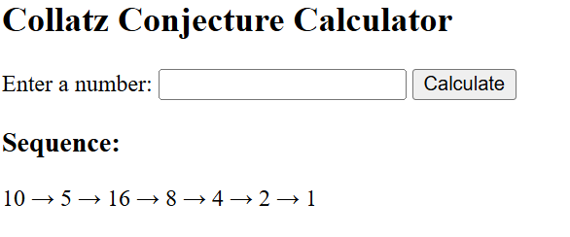
Figure 2: Input 10 and it gives output

Explanation:
This PHP program calculates the Collatz Conjecture for any positive number. The user enters a number, and the program repeatedly applies the rules: divide by 2 if even, or multiply by 3 and add 1 if odd, until the number becomes 1. Each step of the sequence is displayed, showing how the number eventually reaches 1. For example, input 6 gives: 6 → 3 → 10 → 5 → 16 → 8 → 4 → 2 → 1.

